# Multiple 3d Apples Detection/Segmentation from a 3d Point Cloud

## Intro

This project includes python code to detect and segment apples from a point cloud of apple trees.

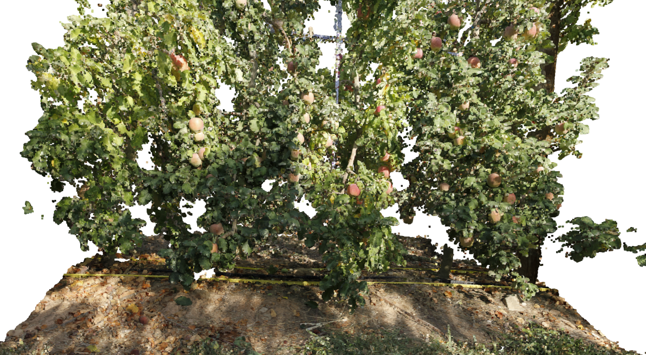

The problem is addressed in two main steps, colour clustering and sphere fitting. In the first main step, the points were clustered by colour with the clustering algorithm DBSCAN [1] to extract the inliers, the apple points from the outliers, the tree points. In the second main step, the script fit multiple 3d spheres to the extracted points by a combination of 3d Hough Transform [2] and RANSAC [3] algorithm . The apples are assumed to spheres with size between 0.06 and 0.10 m. Therefore, their rhos range from 0.03 to 0.05 m. At the end the scripts save the fitted apple points and the spheres parameters which are the centres coordinates and the rhos.

## Results

These methods found 84 apples in about 6 minutes (in my local machine which is slow). The picture below shows the apple trees without the segmented apples. these were replace by the found spheres.

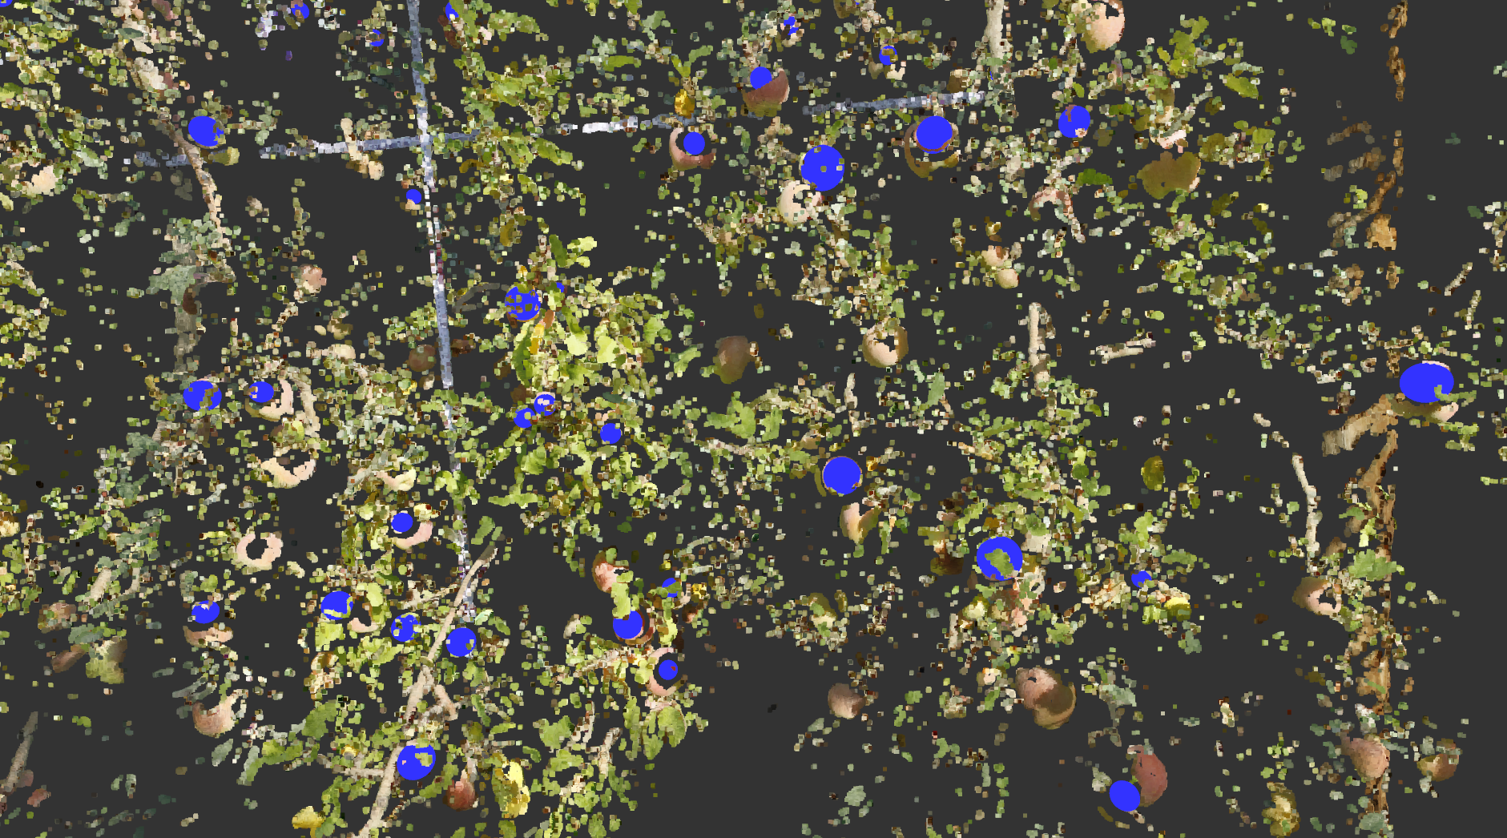

Instead, the following picture displays the segmented apples by the method.

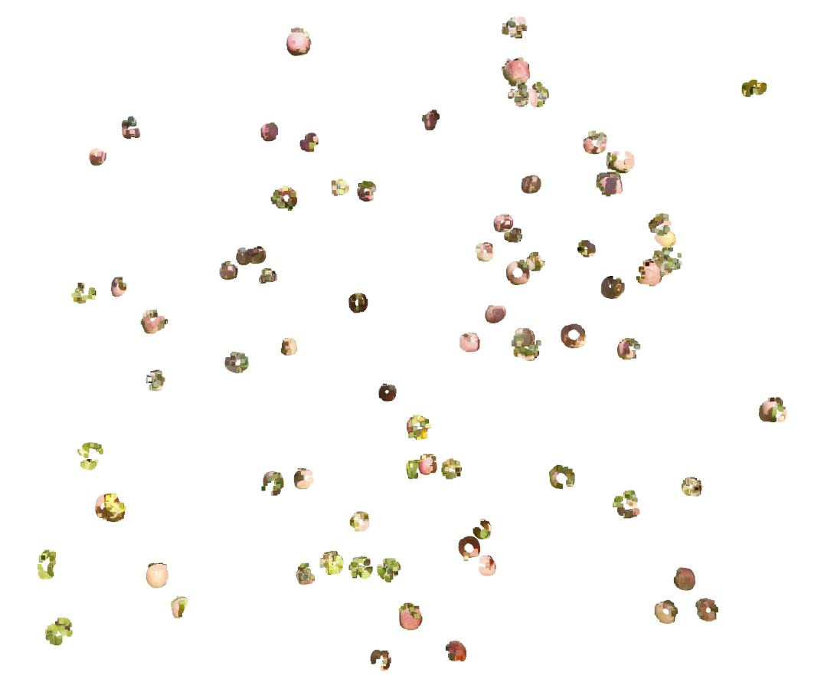

## Conclusion

The two images show that apples were accurately detected and segmented. Yet, the performance was not perfect since there are some false positives and some false negatives. For instance, the apples in the shadows were darker and were filtered away (false negatives). These issues may be solved by tuning the illumination of the points.

## References

[1] M. Ester, H.-P. Kriegel, J. Sander, and X. Xu, "A density-based algorithm for discovering clusters in large spatial databases with noise," in *kdd*, 1996, vol. 96, no. 34, pp. 226-231.

[2] A. Abuzaina, M. S. Nixon, and J. N. Carter, "Sphere Detection in Kinect Point Clouds via the 3D Hough Transform," Berlin, Heidelberg, 2013: Springer Berlin Heidelberg, in Computer Analysis of Images and Patterns, pp. 290-297.

[3] M. A. Fischler and R. C. Bolles, "RANDOM SAMPLE CONSENSUS - A PARADIGM FOR MODEL-FITTING WITH APPLICATIONS TO IMAGE-ANALYSIS AND AUTOMATED CARTOGRAPHY," (in English), *Communications of the Acm,* Article vol. 24, no. 6, pp. 381-395, 1981, doi: 10.1145/358669.358692.